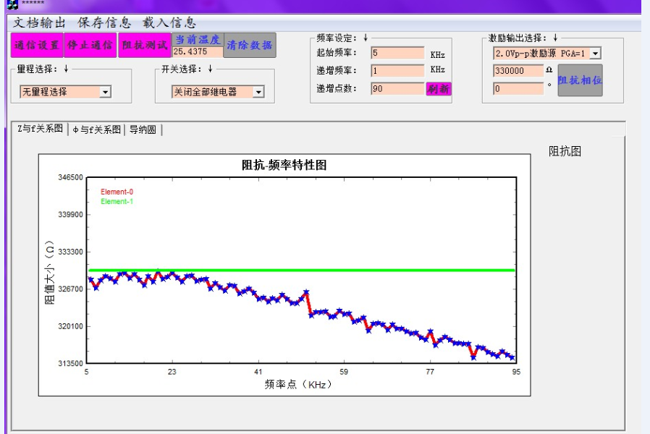

VDD是3.3V
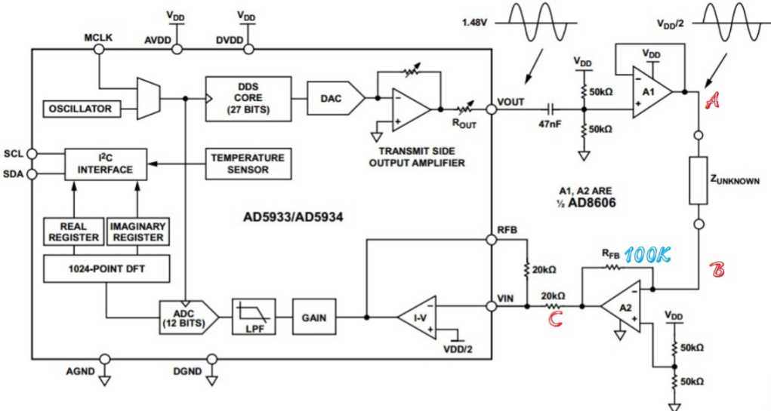
运放用的是ADA4084
电阻我都都在LCR测量仪测试过,5KHz-100KHz对应的阻值误差不大于百分之二,基本是条水平线.
我查了下A、B、C三个点的电压情况,在示波器上显示如下

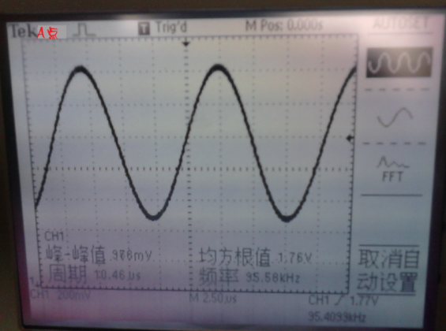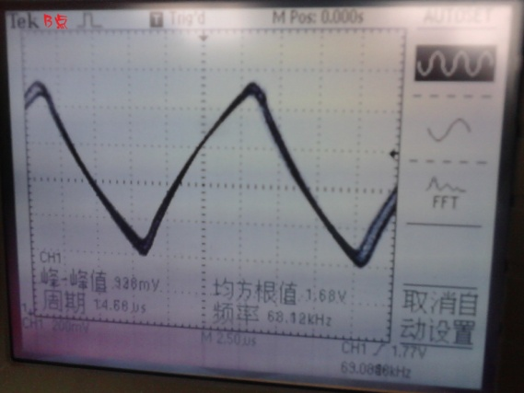

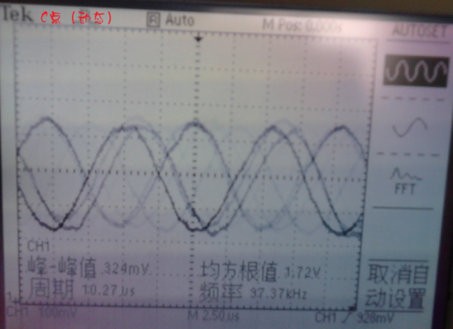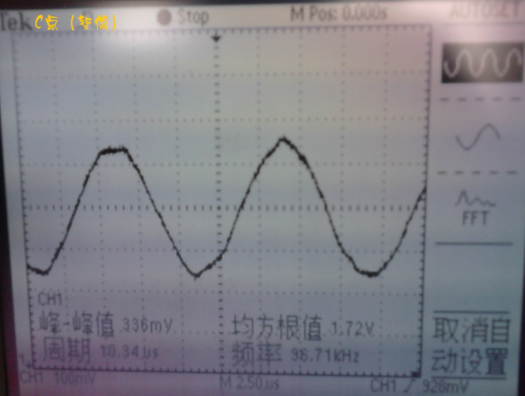

数据我也有：

100KΩ Rf | 100K—R | 100K—X |  | 100KΩ Rf | 330K—R | 330K—X
5KHz | 226 | -4599 |  | 5KHz | 71 | -1400
6KHz | 304 | -4600 |  | 6KHz | 93 | -1400
7KHz | 384 | -4600 |  | 7KHz | 121 | -1404
8KHz | 438 | -4588 |  | 8KHz | 117 | -1400
9KHz | 504 | -4578 |  | 9KHz | 139 | -1396
10KHz | 561 | -4573 |  | 10KHz | 152 | -1394
11KHz | 641 | -4566 |  | 11KHz | 172 | -1401
12KHz | 695 | -4546 |  | 12KHz | 177 | -1388
13KHz | 754 | -4538 |  | 13KHz | 190 | -1382
14KHz | 820 | -4533 |  | 14KHz | 212 | -1387
15KHz | 887 | -4524 |  | 15KHz | 230 | -1385
16KHz | 944 | -4500 |  | 16KHz | 243 | -1379
17KHz | 1012 | -4489 |  | 17KHz | 260 | -1379
18KHz | 1073 | -4481 |  | 18KHz | 276 | -1374
19KHz | 1145 | -4466 |  | 19KHz | 298 | -1379
20KHz | 1198 | -4446 |  | 20KHz | 304 | -1361
21KHz | 1260 | -4428 |  | 21KHz | 324 | -1364
22KHz | 1317 | -4414 |  | 22KHz | 342 | -1361
23KHz | 1381 | -4400 |  | 23KHz | 358 | -1360
24KHz | 1442 | -4374 |  | 24KHz | 374 | -1352
25KHz | 1502 | -4356 |  | 25KHz | 387 | -1354
26KHz | 1557 | -4333 |  | 26KHz | 410 | -1340
27KHz | 1623 | -4315 |  | 27KHz | 424 | -1337
28KHz | 1677 | -4284 |  | 28KHz | 441 | -1329
29KHz | 1739 | -4267 |  | 29KHz | 458 | -1328
30KHz | 1796 | -4236 |  | 30KHz | 473 | -1328
31KHz | 1857 | -4214 |  | 31KHz | 490 | -1331
32KHz | 1913 | -4187 |  | 32KHz | 496 | -1313
33KHz | 1971 | -4161 |  | 33KHz | 516 | -1314
34KHz | 2025 | -4137 |  | 34KHz | 530 | -1313
35KHz | 2085 | -4108 |  | 35KHz | 552 | -1291
36KHz | 2145 | -4071 |  | 36KHz | 572 | -1290
37KHz | 2190 | -4046 |  | 37KHz | 588 | -1280
38KHz | 2256 | -4015 |  | 38KHz | 603 | -1280
39KHz | 2306 | -3989 |  | 39KHz | 613 | -1271
40KHz | 2362 | -3956 |  | 40KHz | 626 | -1267
41KHz | 2416 | -3919 |  | 41KHz | 644 | -1258
42KHz | 2464 | -3889 |  | 42KHz | 658 | -1257
43KHz | 2517 | -3849 |  | 43KHz | 682 | -1244
44KHz | 2577 | -3817 |  | 44KHz | 693 | -1235
45KHz | 2625 | -3785 |  | 45KHz | 701 | -1229
46KHz | 2679 | -3747 |  | 46KHz | 723 | -1219
47KHz | 2726 | -3708 |  | 47KHz | 736 | -1211
48KHz | 2779 | -3670 |  | 48KHz | 755 | -1207
49KHz | 2820 | -3634 |  | 49KHz | 765 | -1201
50KHz | 2875 | -3587 |  | 50KHz | 777 | -1188
51KHz | 2929 | -3559 |  | 51KHz | 795 | -1166
52KHz | 2977 | -3507 |  | 52KHz | 820 | -1176
53KHz | 3022 | -3467 |  | 53KHz | 825 | -1161
54KHz | 3069 | -3431 |  | 54KHz | 843 | -1146
55KHz | 3119 | -3384 |  | 55KHz | 854 | -1140
56KHz | 3159 | -3344 |  | 56KHz | 874 | -1134
57KHz | 3211 | -3296 |  | 57KHz | 889 | -1130
58KHz | 3248 | -3249 |  | 58KHz | 897 | -1108
59KHz | 3297 | -3205 |  | 59KHz | 913 | -1095
60KHz | 3343 | -3162 |  | 60KHz | 927 | -1093
61KHz | 3378 | -3114 |  | 61KHz | 941 | -1076
62KHz | 3421 | -3063 |  | 62KHz | 959 | -1068
63KHz | 3465 | -3023 |  | 63KHz | 975 | -1058
64KHz | 3509 | -2970 |  | 64KHz | 986 | -1049
65KHz | 3544 | -2922 |  | 65KHz | 993 | -1043
66KHz | 3583 | -2873 |  | 66KHz | 1008 | -1021
67KHz | 3621 | -2818 |  | 67KHz | 1028 | -1014
68KHz | 3659 | -2774 |  | 68KHz | 1036 | -1003
69KHz | 3693 | -2718 |  | 69KHz | 1047 | -985
70KHz | 3731 | -2668 |  | 70KHz | 1059 | -971
71KHz | 3768 | -2617 |  | 71KHz | 1071 | -957
72KHz | 3805 | -2568 |  | 72KHz | 1090 | -947
73KHz | 3836 | -2506 |  | 73KHz | 1103 | -936
74KHz | 3866 | -2458 |  | 74KHz | 1109 | -919
75KHz | 3902 | -2407 |  | 75KHz | 1126 | -913
76KHz | 3934 | -2350 |  | 76KHz | 1135 | -897
77KHz | 3965 | -2297 |  | 77KHz | 1144 | -879
78KHz | 3995 | -2238 |  | 78KHz | 1158 | -862
79KHz | 4019 | -2183 |  | 79KHz | 1163 | -849
80KHz | 4051 | -2127 |  | 80KHz | 1181 | -840
81KHz | 4079 | -2075 |  | 81KHz | 1194 | -816
82KHz | 4107 | -2015 |  | 82KHz | 1198 | -813
83KHz | 4134 | -1958 |  | 83KHz | 1212 | -796
84KHz | 4157 | -1900 |  | 84KHz | 1221 | -779
85KHz | 4188 | -1841 |  | 85KHz | 1229 | -763
86KHz | 4201 | -1779 |  | 86KHz | 1241 | -750
87KHz | 4227 | -1725 |  | 87KHz | 1247 | -735
88KHz | 4253 | -1669 |  | 88KHz | 1266 | -721
89KHz | 4265 | -1610 |  | 89KHz | 1274 | -704
90KHz | 4284 | -1551 |  | 90KHz | 1283 | -694
91KHz | 4303 | -1490 |  | 91KHz | 1286 | -675
92KHz | 4332 | -1432 |  | 92KHz | 1299 | -659
93KHz | 4346 | -1365 |  | 93KHz | 1305 | -647
94KHz | 4361 | -1312 |  | 94KHz | 1314 | -623

我求的是每个频率的增益因子，不是定两点，再校准的，所以没有校准这一说
我示范5KHz和90KHz的计算方式
5KHz的情况下： 90KHz的情况下：
RX-Z(5KHz-100KΩ)=4565 RX-Z(90KHz-100KΩ)=4556
RX-Z(5KHz-330KΩ)=1402 RX-Z(90KHz-330KΩ)=1459
真实-Z=100KΩ*4565/1402=325.6 KΩ 真实-Z=100KΩ*4556/1459=312.3 KΩ

