Mixed waveguide/coax calibration confusion

We are trying to do a four port cal on a dual directional coupler, where our DUT is waveguide to waveguide on the thru ports, and coax at the coupled ports. We have a coax to waveguide adapter at each waveguide port connected to the PNA-X ports 1 and 2. These will be left on when we measure our DUT. Ports 3 and 4 have normal coax test cables that will later connect to the coupled DUT ports.
We choose the smart cal, and select 4-ports. The PNA-X is set up for ports 1 and 2 to our waveguide type and the appropriate TRL cal kit, and ports 3 and 4 to the coax connector type, with the ECAL chosen. We check Modify cal, the next. We get the following dialog box. For some waveguide cal kits, instead of defaulting to Unknown thru, it defaults to Adapter Removal. So the first question is, what determines what the default selection is, and does it matter what we select. Obviously, unknown thru is much simpler, so we would rather do that.
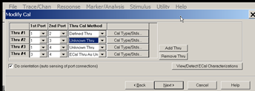
The other question about this dialog is, what is the unknown thru? Is the coax to waveguide adapter considered the unknown thru since we have to adapt the coax to the waveguide anyways? This will put the adapter connected to port 1 or 2 connected to our new adapter for port 3 or 4. The answer to this might relate to the next paragraph.
When we start to do the actual cals, the waveguide to waveguide TRL cal is obvious, and the coax to coax Ecal cal is obvious. Then we come to the Waveguide to coax portion of the cal, one for port 3 and one for port 4. The dialog below shows port 1/adapter/port 3. Is this the coax to waveguide adapter, so the complete path would be:
PNA-X port 1 ->coax test cable-> permanently connected coax to waveguide adapter -> temporary coax to waveguide -> coax test cable ->PNA-X port 3.
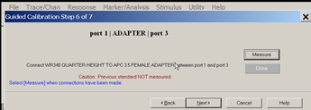
Is this understanding and method correct?

