Please see the following commands to determine which will work best for you:

:READ:LPLot[n]?

:CALCulate:LPLot:MARKer[1]|2|...12:Y?

Here is the SCPI to turn on/off the marker table:

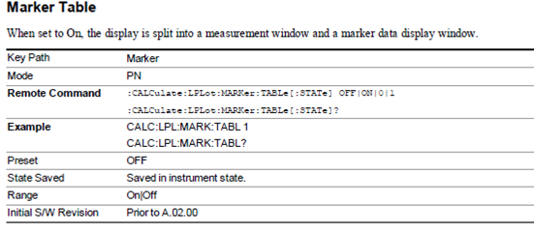

Page 672:

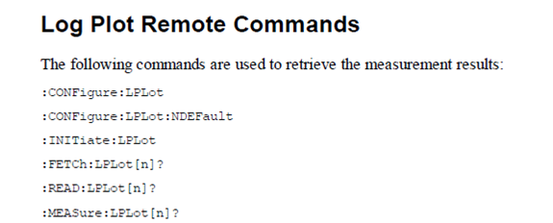

Page 708-709:

