When doing a waveform capture you want to take the fastest readings possible. You can see the settings I used in the picture below.
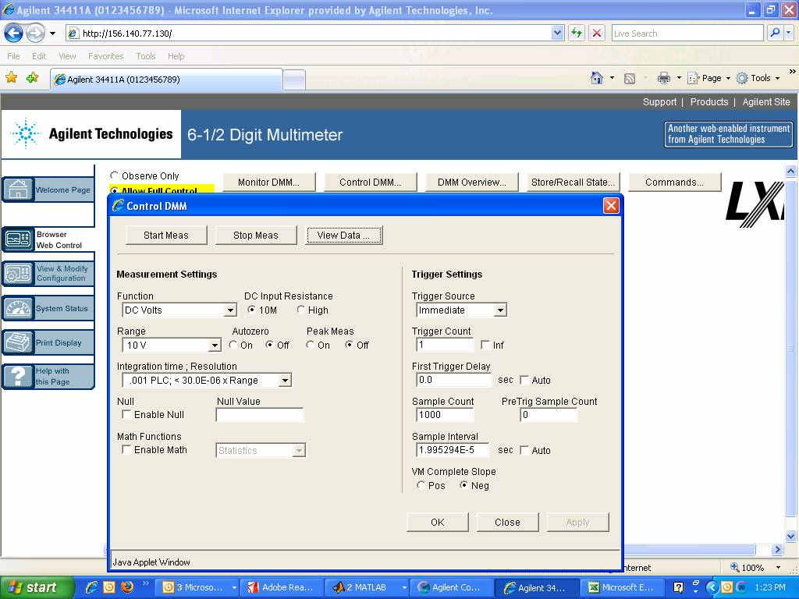
Once I had the setting I wanted I clicked apply and then start meas. Once the measurement is complete I clicked on the View Data button. Below is the settings I used in the View Data. As you can see I only read 500 of the 1000 readings stored in the memory. Click the Get Data button and the values will be shown as in the picture below.
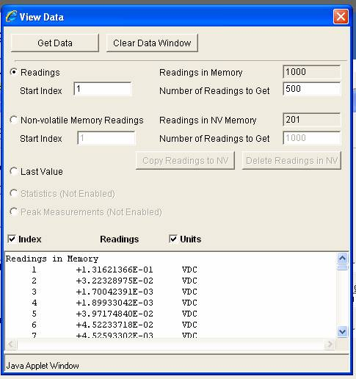
Once you get the readings you can copy and paste those readings into Microsoft excel and create a graph. The resulting graph is the so called waveform capture. This is the actual graph I got from the readings above. It is a heartbeat waveform that was generated by a function generator.

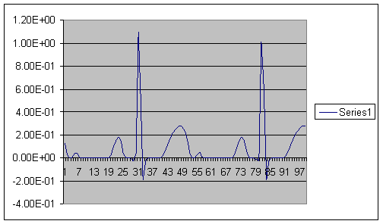

As you can see the waveform capture is just a graph of data points taken by the 34411A. The reason we are able to get such an accurate graph of the waveform is a direct result of the high sampling rate that the 34411A is capable of performing.

You can graph the waveform with any program of your preference. I just used excel as an example, I’ve done these plots in Matlab as well and I’m sure there is many other programs capable of generating these plots.

