**THRU response with and without 50 dB PAD**

Calibration has been performed at IF BW = 1KHz, Freq Range (1.3 GHz to 1.4 GHz), Power Level = 0 dBm, Averaging = off.

There is no difference in results when i used frequency range 50 MHz to 6 GHz during Calibration.

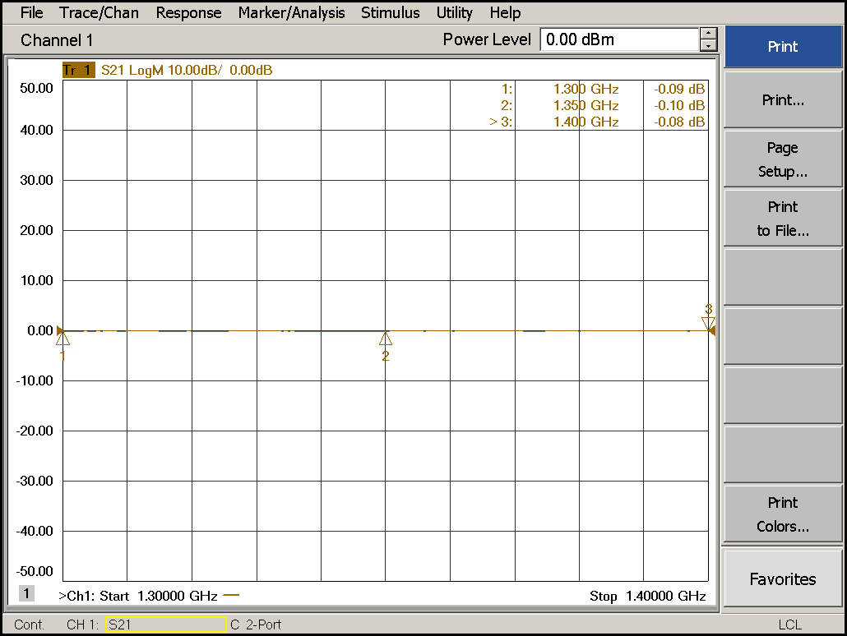

**Fig. 1- Two Full Port SOLT Calibration (Magnitude response without 50 dB PAD)**

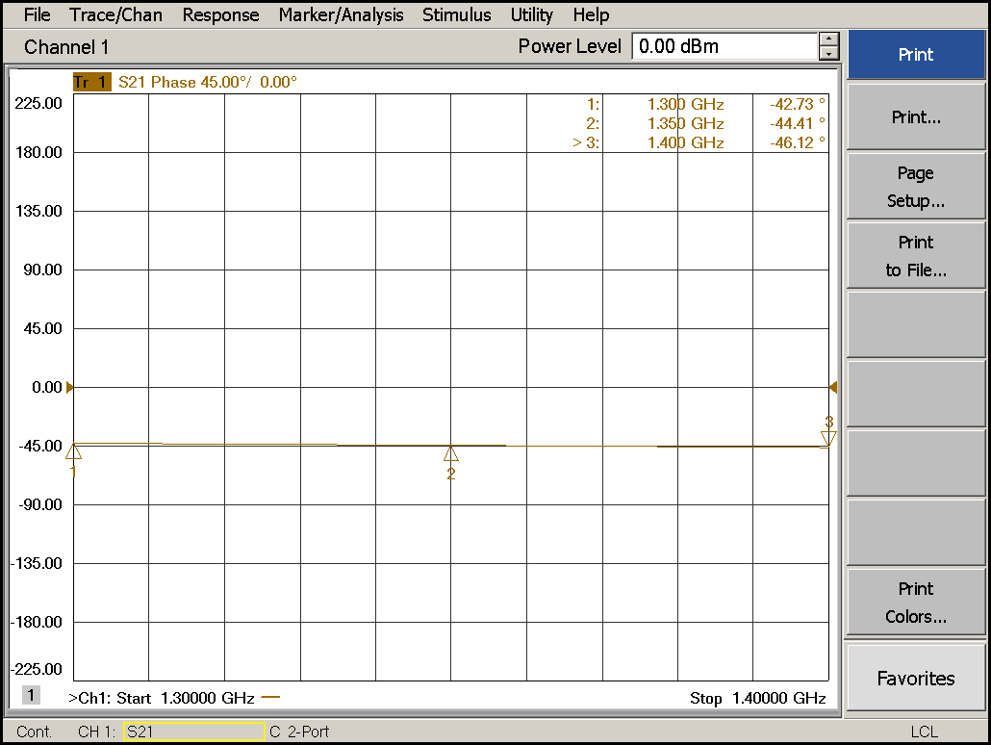

**Fig. 2- Two Full Port SOLT Calibration (Phase response without 50 dB PAD)**

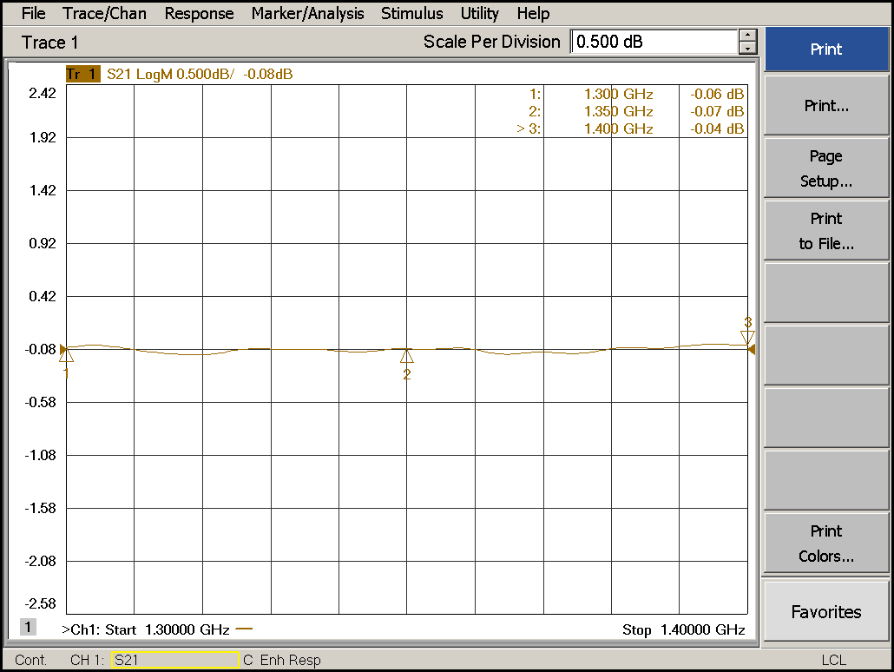

**Fig. 3- Enhanced Response (Using Ecal User Characterization) Calibration (Magnitude response without 50 dB PAD). We are comparing this result with thru response of 2 full port SOLT Calibration as shown in Fig. 1.**

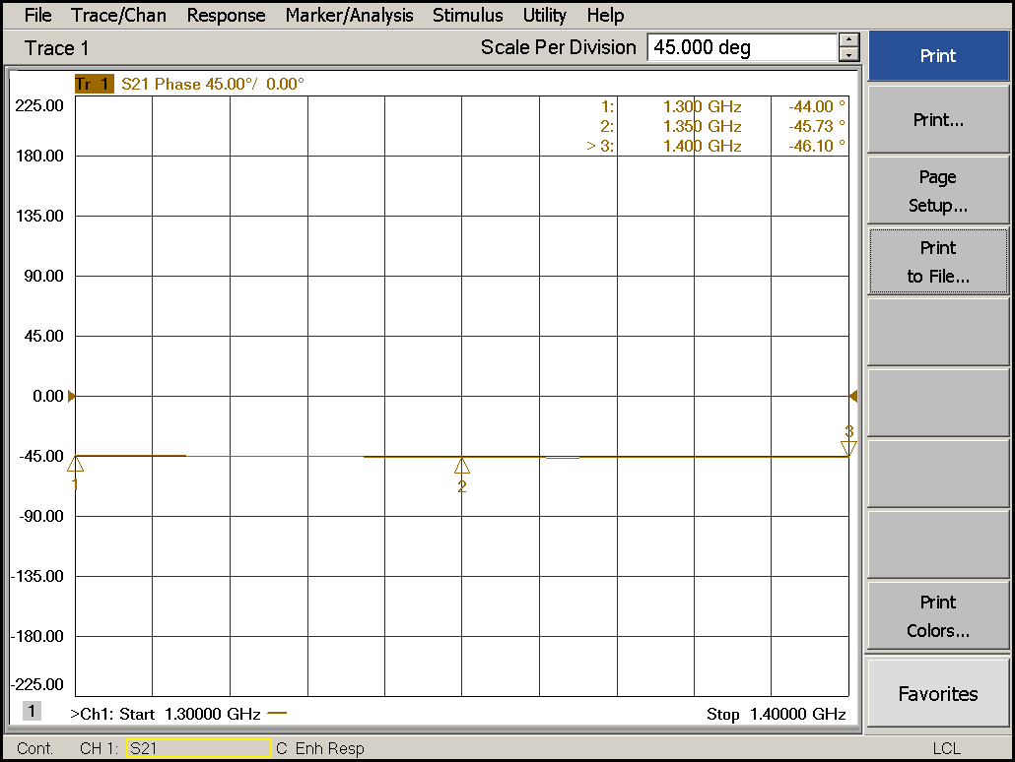

**Fig. 4- Enhanced Response (Using Ecal User Characterization) Calibration (Phase response without 50 dB PAD). We are comparing this result with thru response of 2 full port SOLT Calibration as shown in Fig. 2.**

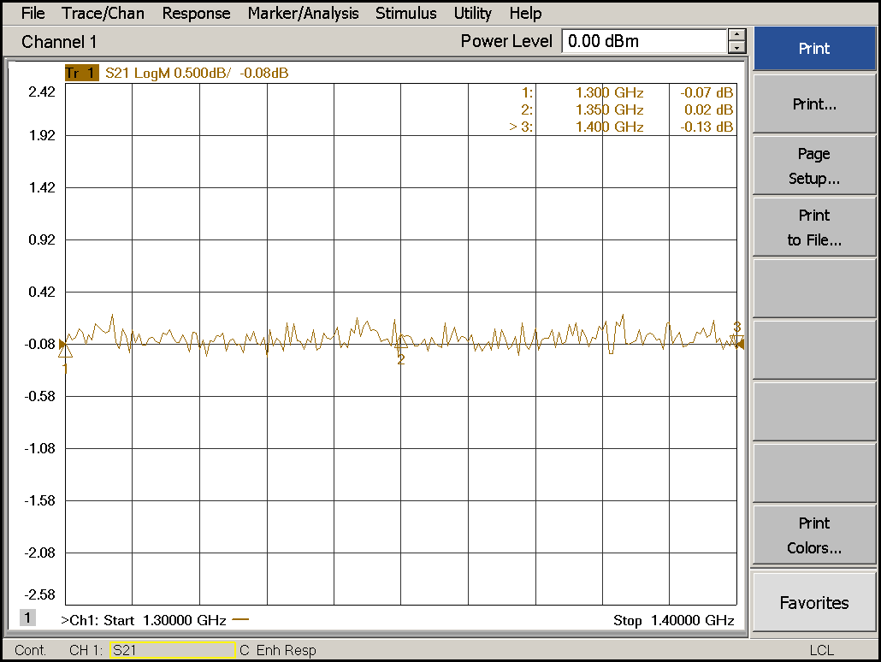

**Fig. 5- Enhanced Response (Using Ecal User Characterization) Calibration (Magnitude response with 50 dB PAD). (IF BW=1 KHz, Avg = off)**

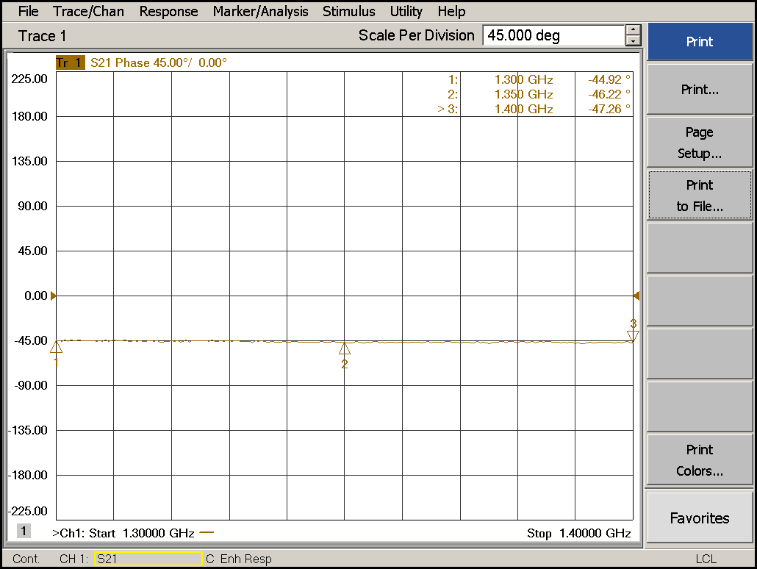

**Fig. 6- Enhanced Response (Using Ecal User Characterization) Calibration (Phase response with 50 dB PAD). (IF BW=1 KHz, Avg = off)**

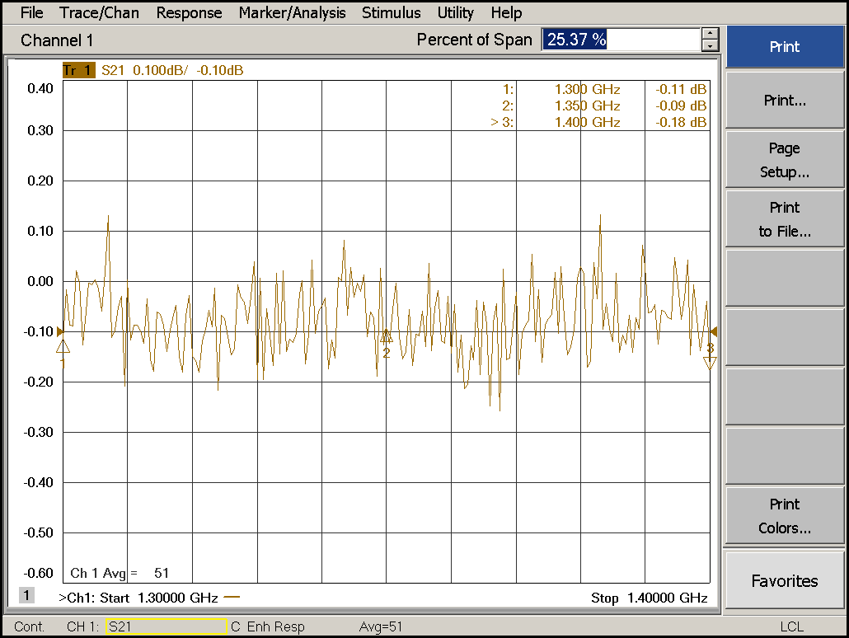

**Fig. 7- Enhanced Response (Using Ecal User Characterization) Calibration (Magnitude response with 50 dB PAD). (IF BW=1 KHz, Avg = On, Averaging factor = 50. Scale = Autoscale)**

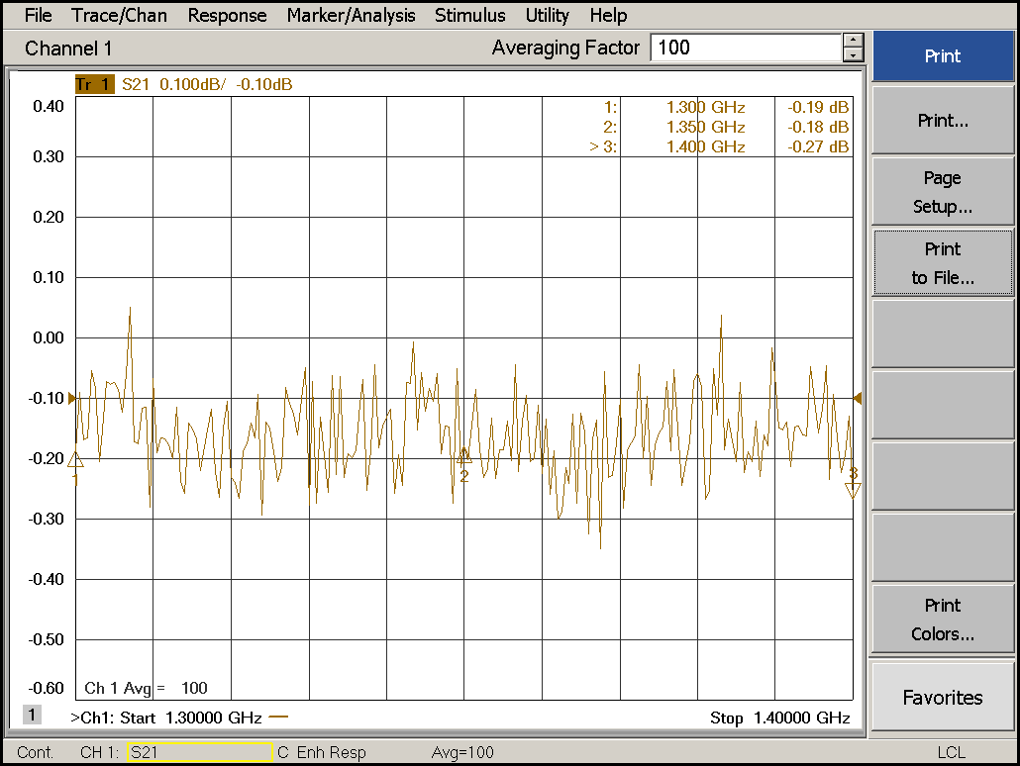

**Fig. 8- Enhanced Response (Using Ecal User Characterization) Calibration (Magnitude response with 50 dB PAD). (IF BW=1 KHz, Avg = On, Averaging factor = 100)**

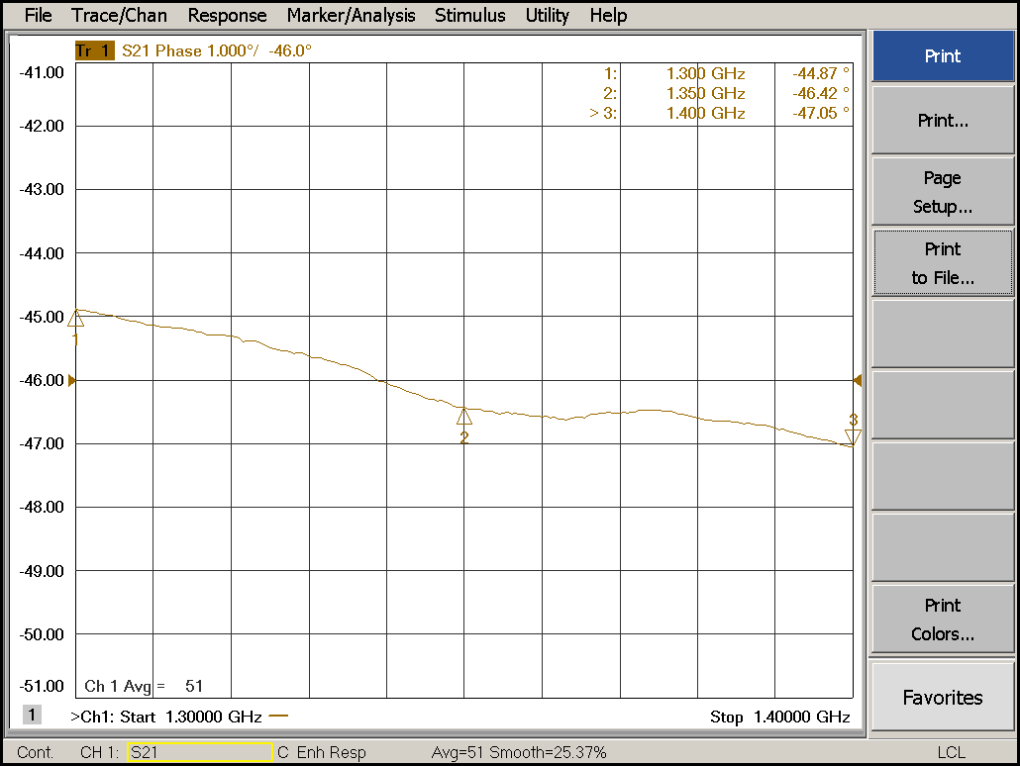

**Fig. 9- Enhanced Response (Using Ecal User Characterization) Calibration (Phase response with 50 dB PAD). (IF BW=1 KHz, Avg = On, Averaging factor = 50, Smoothing = On, Points = 50)**