Screen shot showing the import of the 2 User Functions.

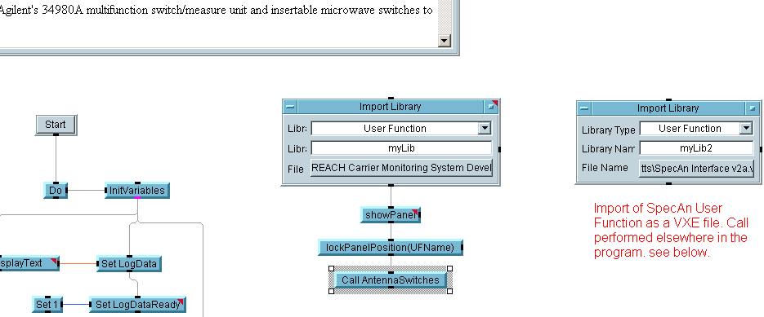

Call to SpecAn interface.

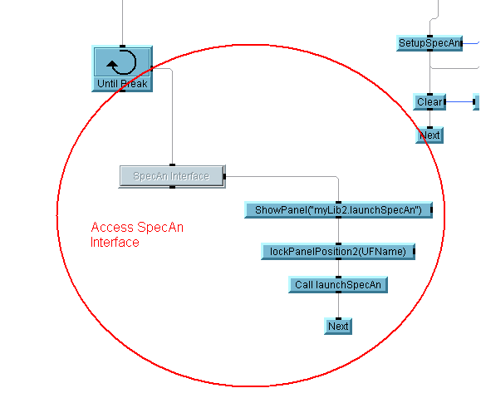

Program run from within VEE 7.5 - activating the SpecAn interface button.

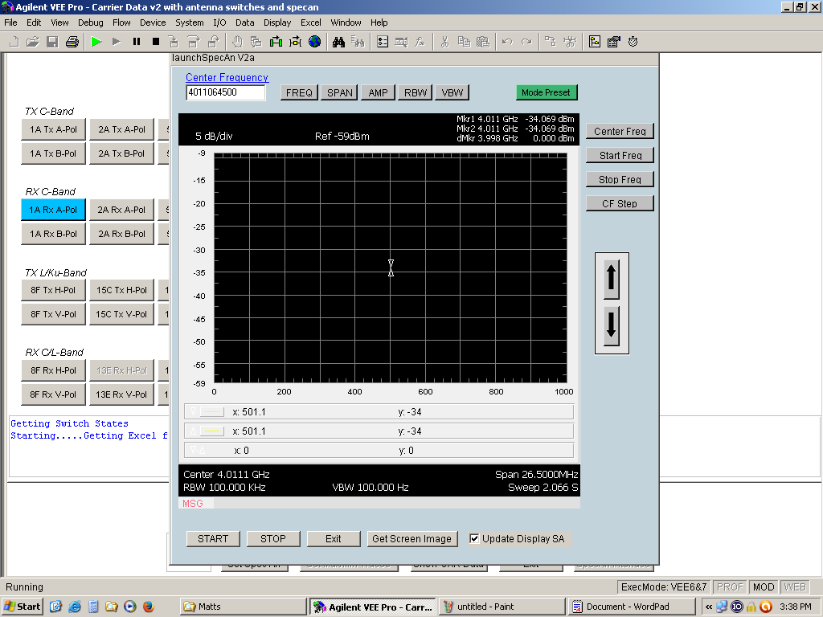

Screen shots when run from the runtime version.

