-Enhanced response calibration (ERC) has been done using ECal user characterization method.

- Measured THRU adaptor response (S21) by taking different IF BW (to reduce noisy trace).

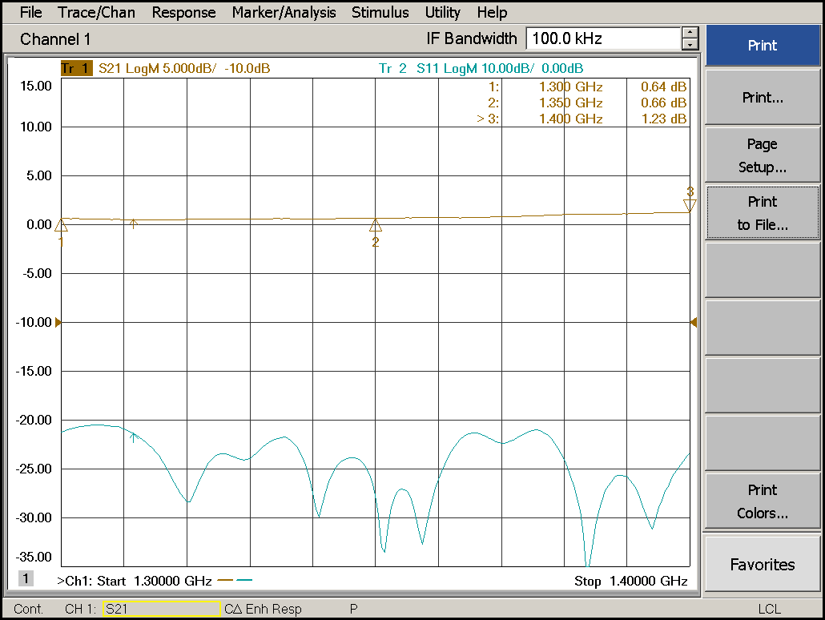

Fig. 1: Thru adapter magnitude response measured without using 50 dB PAD. S11 & S21 show good response after doing ERC.

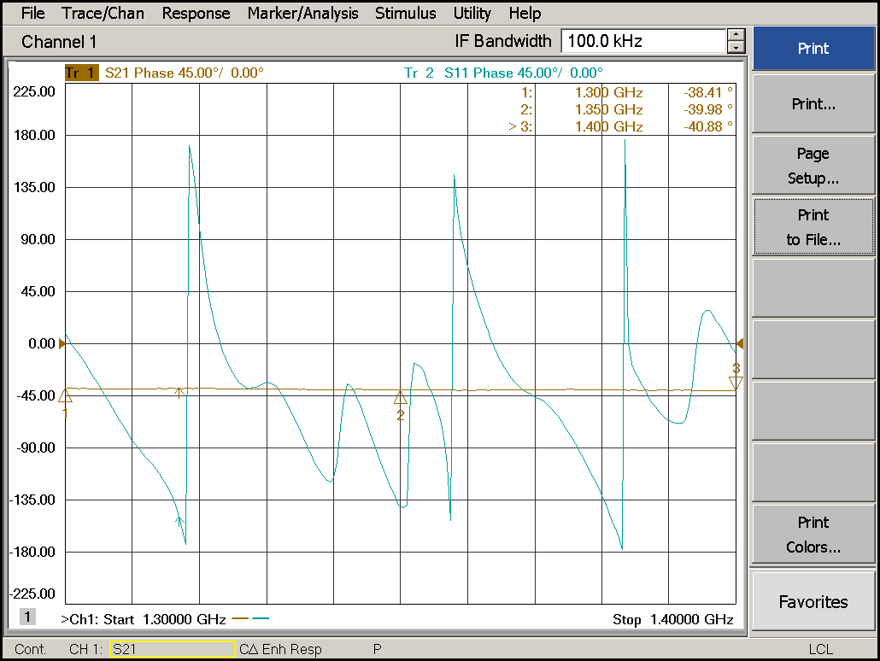

Fig. 2: Thru adapter phase response measured without using 50 dB PAD. S11 & S21 show good response after doing ERC. Both Cases IF BW was 100KHz.

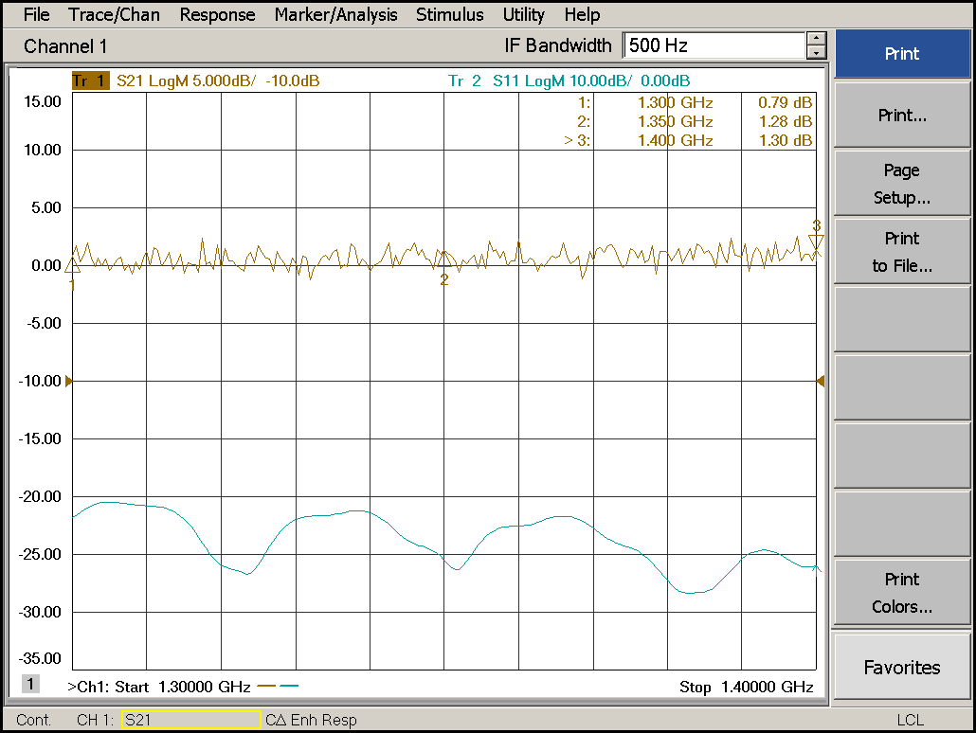

Fig. 3: Thru adapter magnitude response measured using 50 dB PAD. S11 shows smooth response because of no PAD at i/p side. But S21 trace became noisy trace, because of 50 dB PAD at o/p (VNA receiver side). We can’t bypass this attenuator path while doing calibration. Here IF BW was 500 Hz .

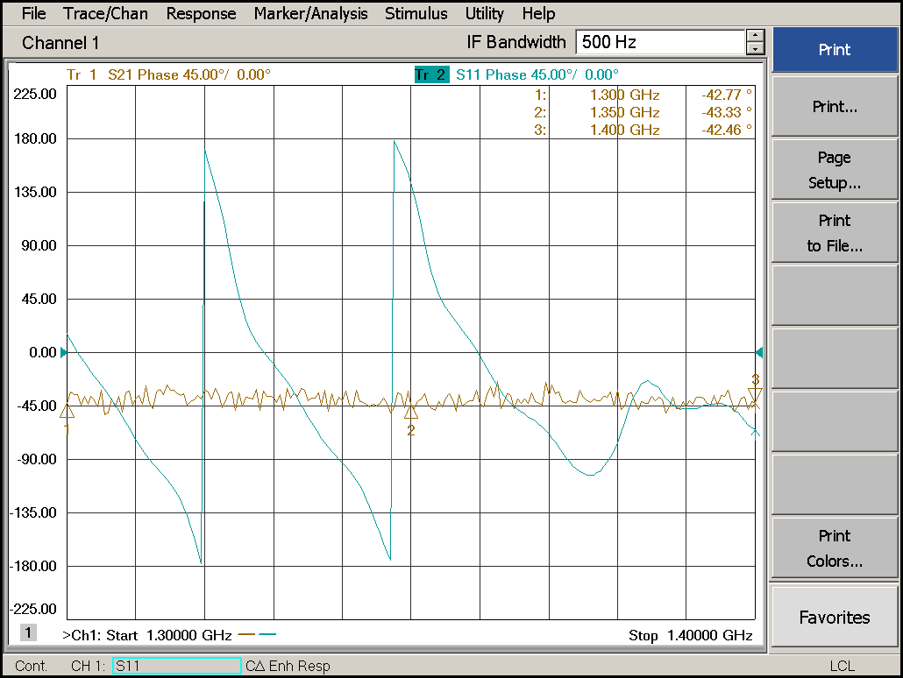

Fig. 4: Thru adapter Phase response measured using 50 dB PAD.

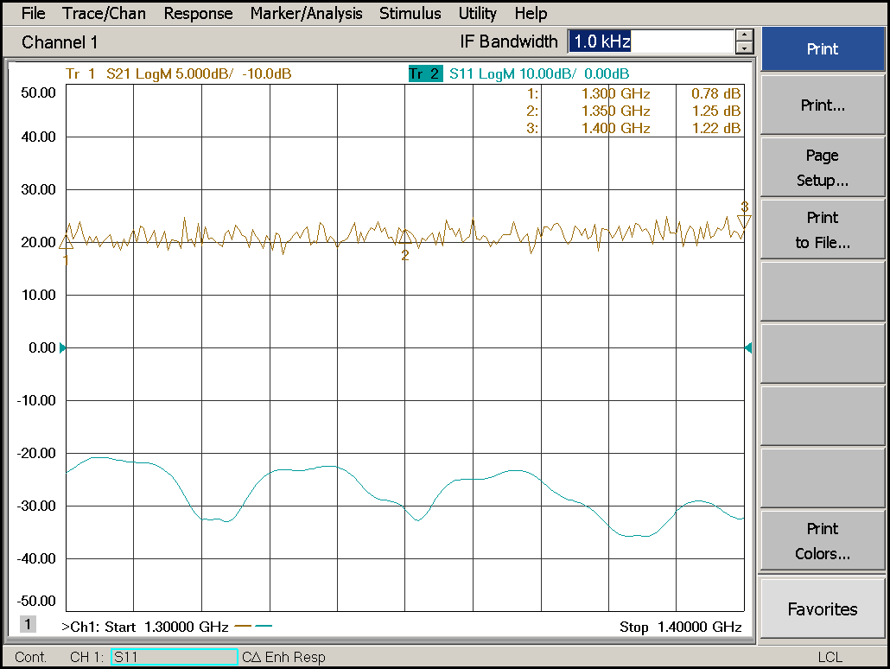

Fig. 5: Thru adapter Magnitude response measured using 50 dB PAD. IF BW=1 KHz.

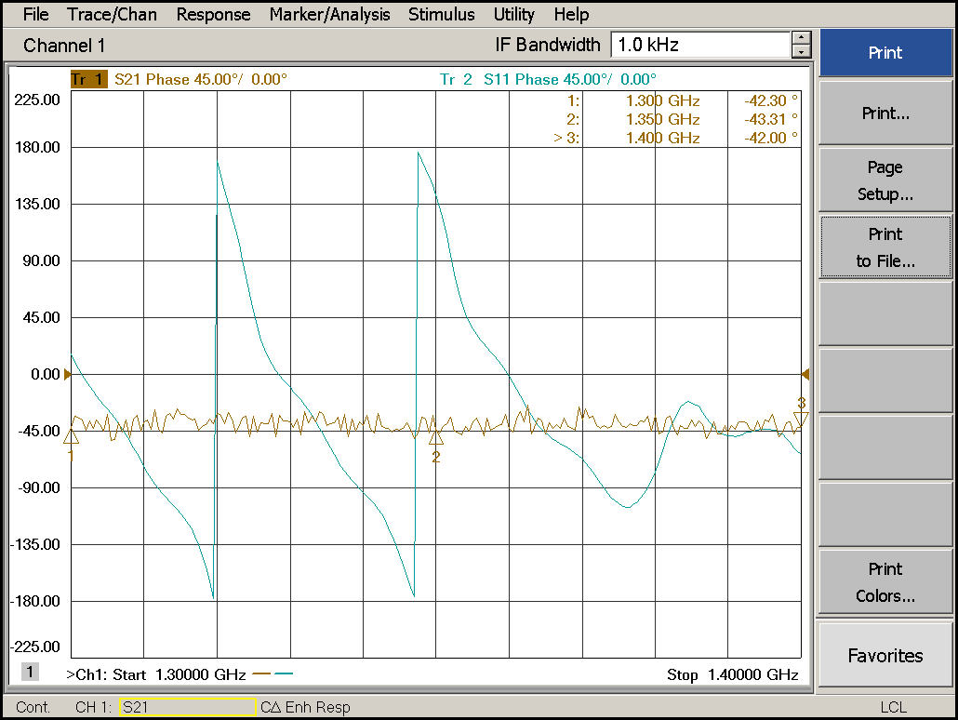

Fig. 6: Thru adapter Phase response measured using 50 dB PAD. IF BW=1 KHz.

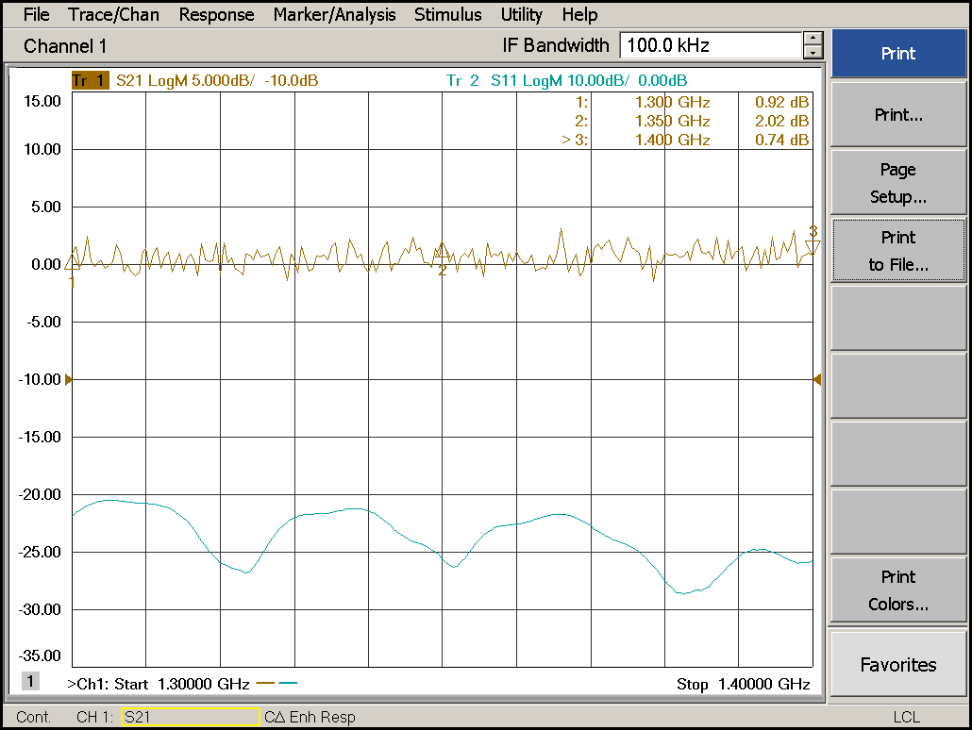

Fig. 7: Thru adapter Magnitude response measured using 50 dB PAD. IF BW=100 KHz.

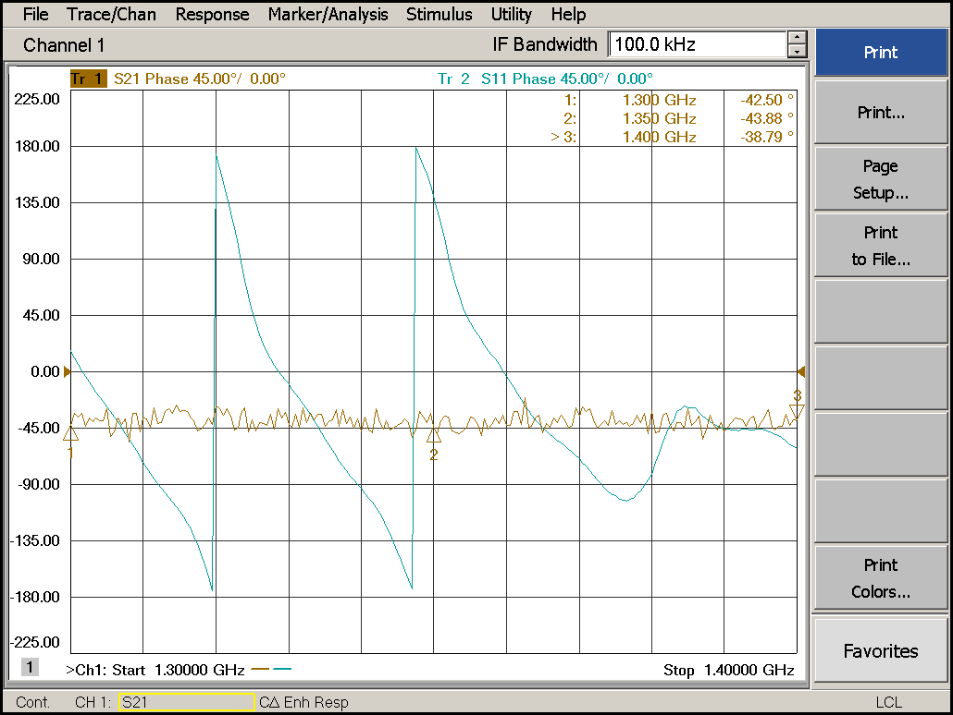

Fig. 8: Thru adapter Phase response measured using 50 dB PAD. IF BW=100 KHz.