Enhanced Response Calibration (using Ecal User Characterization) with 50 dB PAD

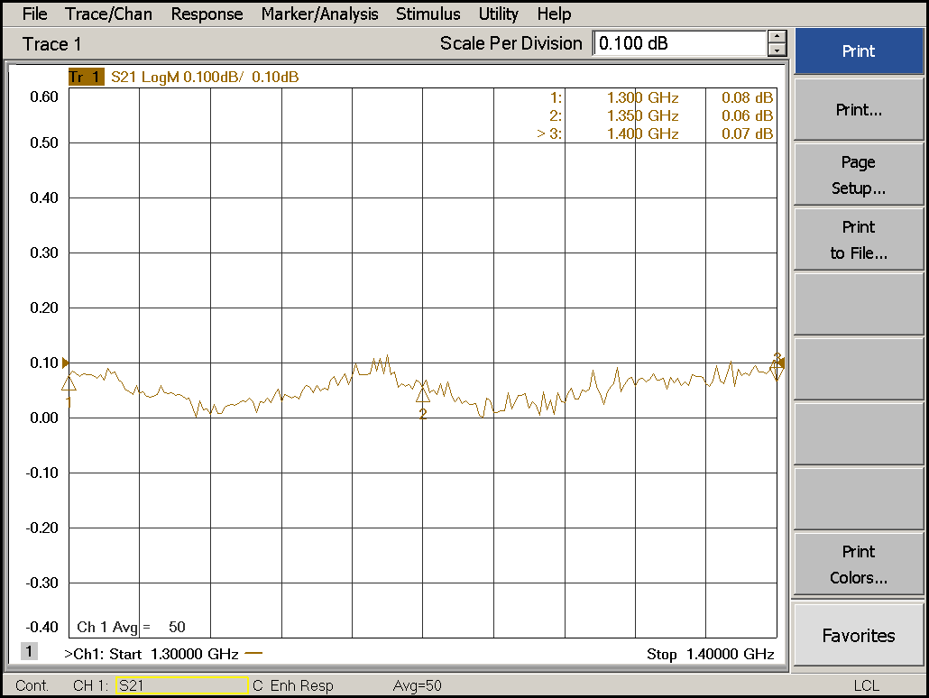
Fig 1: ERC Calibration with 50 dB PAD.
Settings during ERC calibration: IF BW = 1 KHz, No. of Sweep Points = 101, Avg = On, Avg Factor = 50, Sweep Avg.

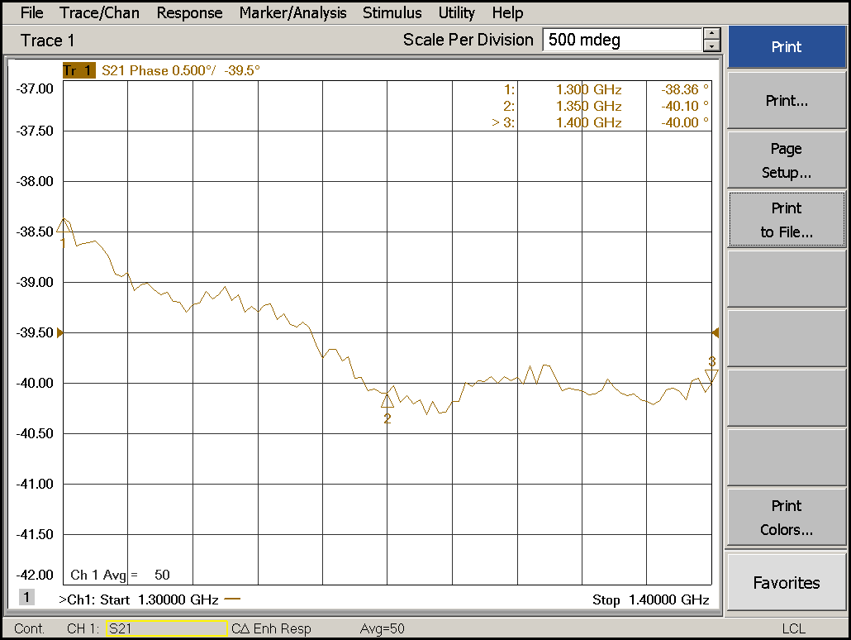
Fig 2: ERC Calibration with 50 dB PAD (Phase Response).
Settings during ERC calibration: IF BW = 1 KHz, Sweep Points = 101, Avg = On, Avg Factor = 50, Sweep Avg.

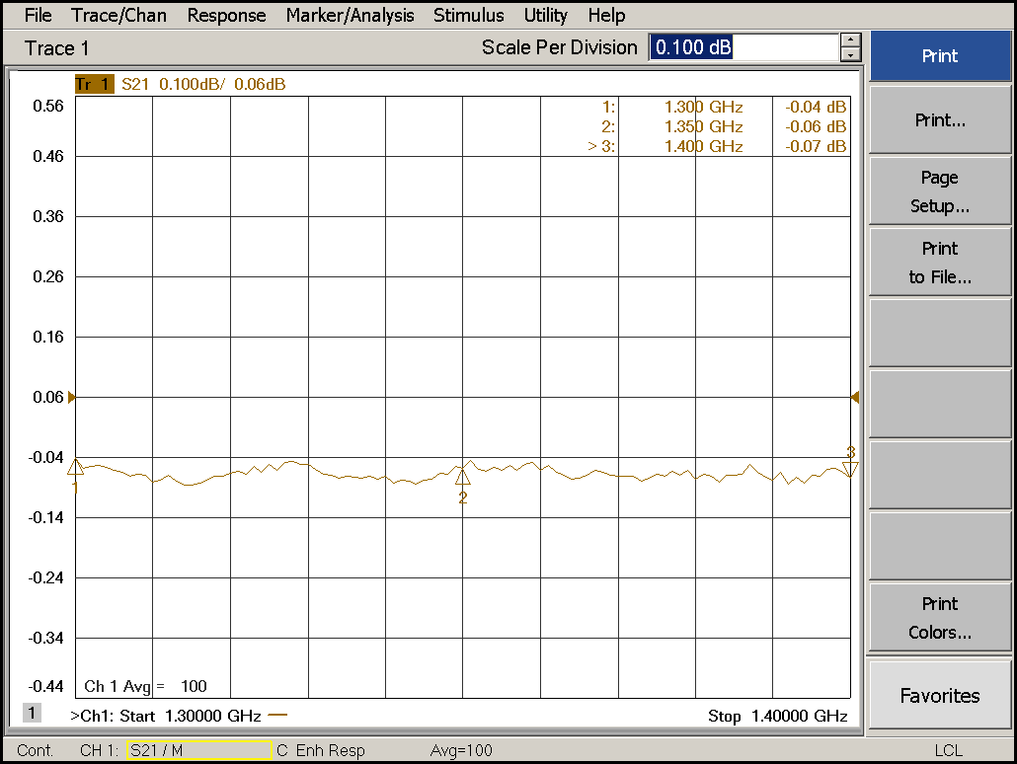
Fig 3: ERC Calibration with 50 dB PAD.
Settings during ERC calibration: IF BW = 1 KHz, Sweep Points = 101, Avg = On, Avg Factor = 100, Sweep Avg.

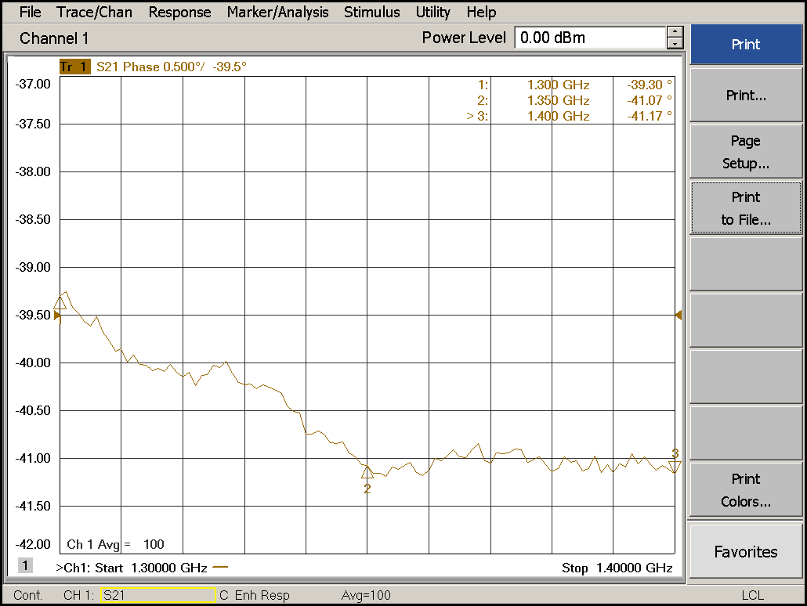
Fig 4: ERC Calibration with 50 dB PAD (Phase Response).
Settings during ERC calibration: IF BW = 1 KHz, Avg = On, Avg Factor = 100, Sweep Avg.

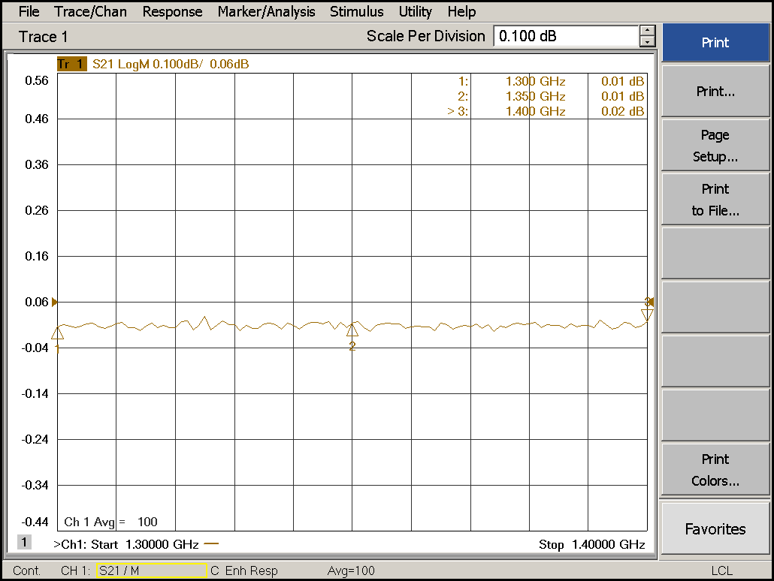
Fig 5: ERC Calibration with 50 dB PAD (Magnitude Response).
Settings during ERC calibration: IF BW = 1 KHz, Avg = On, Avg Factor = 100, Sweep Avg.
After Calibration: Memory -> Data Math -> Data/Memory (S21 result shown in Fig 5).

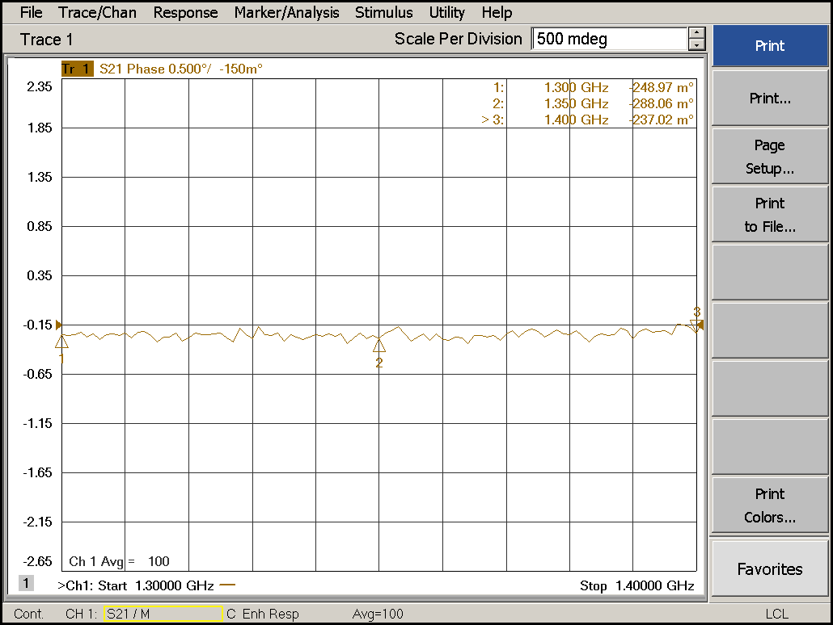
Fig 6: ERC Calibration with 50 dB PAD (Magnitude Response).
Settings during ERC calibration: IF BW = 1 KHz, Avg = On, Avg Factor = 100, Sweep Avg.
After Calibration: Memory -> Data Math -> Data/Memory (S21 result shown in Fig 6).
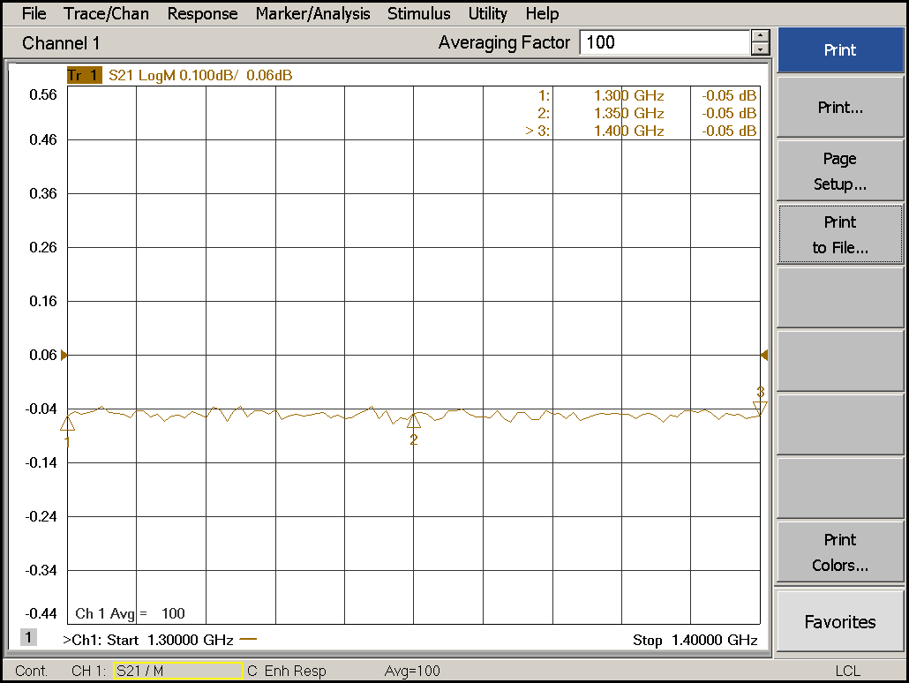
Fig 7: ERC Calibration with 50 dB PAD (Magnitude Response).
Settings during ERC calibration: IF BW = 1 KHz, Avg = On, Avg Factor = 100, Sweep Avg.
After Calibration: Memory -> Data Math -> Data/Memory with Average Restart option (S21 result shown in Fig 7).

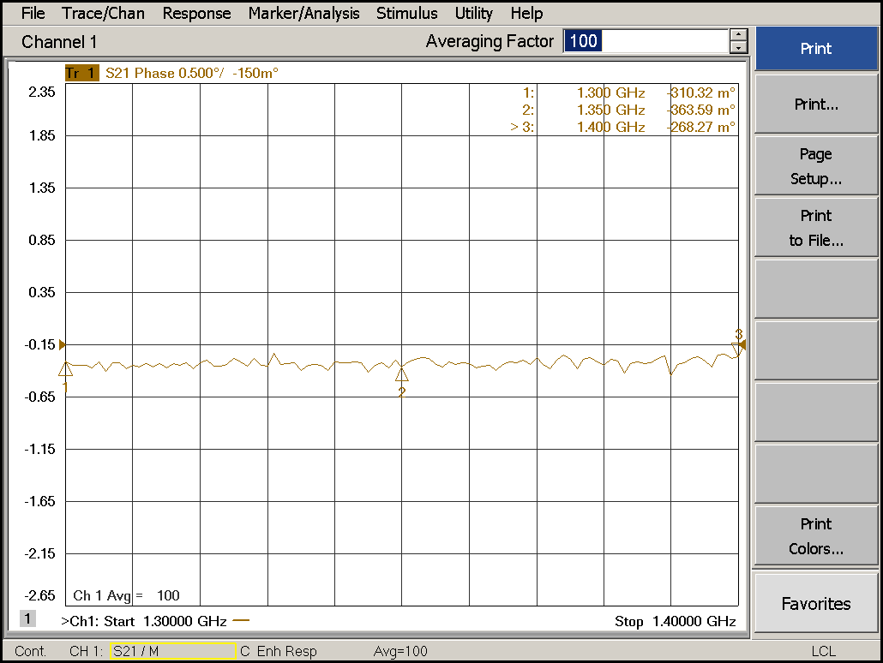
Fig 8: ERC Calibration with 50 dB PAD (Phase Response).
Settings during ERC calibration: IF BW = 1 KHz, Avg = On, Avg Factor = 100, Sweep Avg.
After Calibration: Memory -> Data Math -> Data/Memory with Average Restart option (S21 result shown in Fig 8).
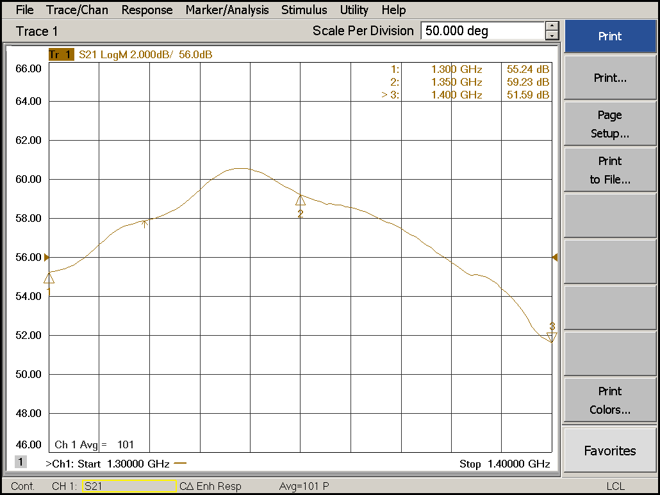
Fig 9: DUT Gain Response.
Settings during Calibration: IF BW = 1 KHz, Sweep Points = 101, Avg = On, Avg Factor = 100, Sweep Avg.
Settings during Measurement: IF BW = 100 KHz (1 KHz IF BW was not working with pulse mode (0.1% duty cycle), Sweep Points = 101, Avg = On, Avg Factor = 100, Sweep Avg.
DUT works at pulse mode. Calibration has been performed in CW mode with above settings.
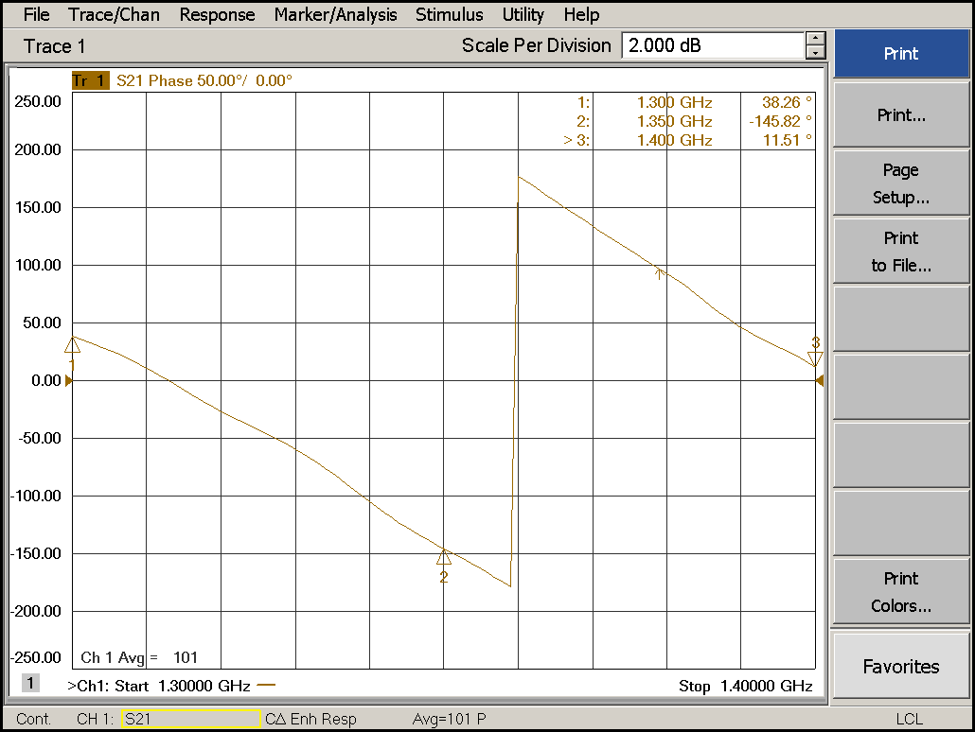
Fig 10: DUT Phase Response.

