Hi,

I am fully automating a calibrated gain compression measurement (GCX) for a mixer/amplifier module but only want to measure SC21. The analyzer is calibrated and measures a fully corrected GCX sweep but I don't want the analyzer to measure the reverse (SC12) direction and I don't need return losses (SC11 and SC22). My preference is to downgrade a full GCX calibration to an "Enhanced Response Cal". I am able to set the "Enhanced Response Cal" manually for only SC21 sweep but unable to do this remotely. Is there a parameter to switch off the SC12 sweep?

To disable the reverse sweep from the front panel navigate to “Select Calibration Type” page by Response -> Cal -> Mange Cals -> Correction Methods… and uncheck all the calibration types.

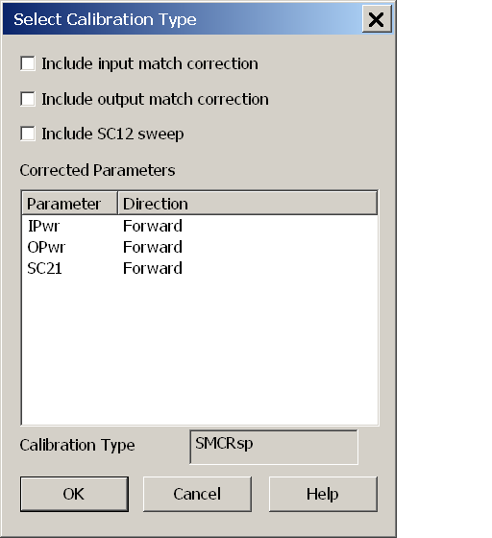

The Calibration Type results in “SMCRsp”. I used the Calibration Type as a parameter but this turns on the reverse measurements.

Ronel