前置：
Api：6
语言：js开发

添加编译依赖参考地址：
https://developer.huawei.com/consumer/cn/doc/development/HMSCore-Guides/harmonyos-js-integration-hms-core-sdk-0000001149139136

需要权限：
ohos.permission.INTERNET
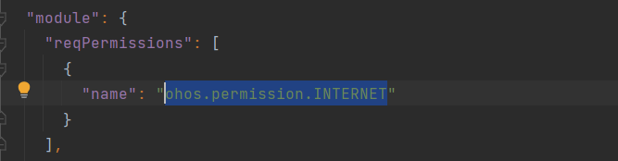

开始：
1.创建项目：
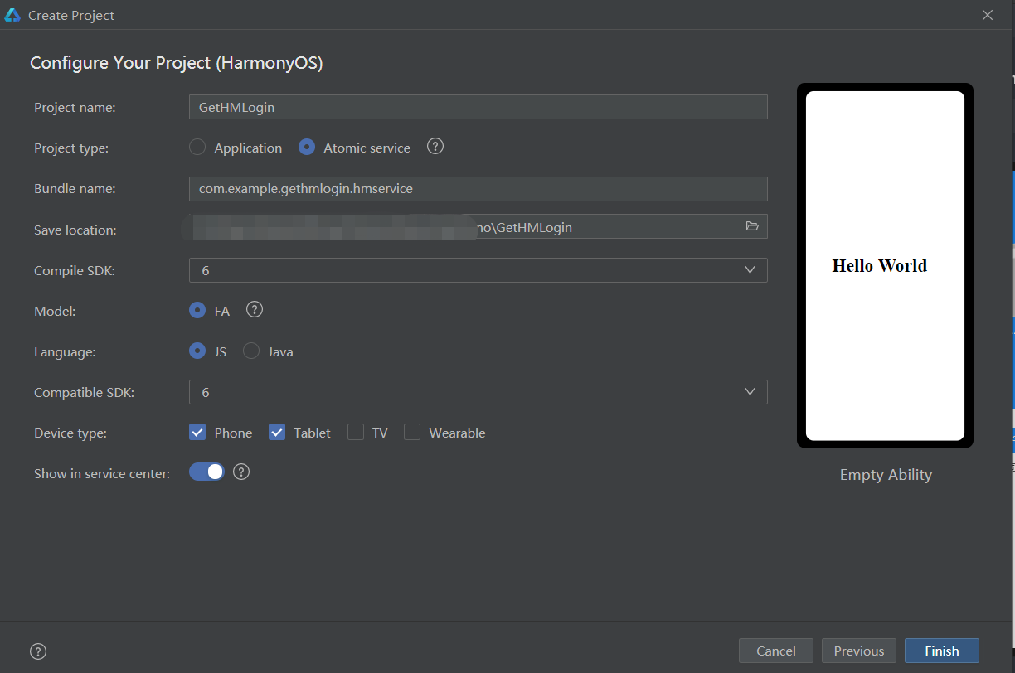

2.示例代码
test.hml
<div class="container">
<!-- 顶部导航-标题-->
<div class="header-router">
<div class="header-box">
<text class="header-box-back" onclick="back">
<span>＜返回</span>
</text>
</div>
</div>
<div class="login-box">
<image class="user-img" src="{{ userImg }}"></image>
<text class="user-name" onclick="goGetUserNumber">
<span>{{ userName }}</span>
</text>
</div>
<text class="btnText" onclick="getNumber">
<span>一键授权华为账号登录</span>
</text>
<div class="changeDiv">
<input type="checkbox" checked="{{ isCheck }}" onchange="changeBtn"></input>
<text class="privacy">
<span>我已阅读并同意</span>
</text>
<text class="privacy" onclick="goPrivacyContent">
<span style="color: dodgerblue;">《用户隐私协议》</span>
</text>
</div>
</div>

test.css
@import '../../common/css/header-router.css';
.container {
flex-direction: column;
justify-content: flex-start;
align-items: center;
width: 100%;
}
.login-box{
flex-direction: column;
justify-content: center;
align-items: center;
width: 100%;
height: 50%;
background-color: dodgerblue;
}
.user-img{
width: 120px;
height: 120px;
border-radius: 60px;
object-fit: cover;
/* border: 1px;*/
background-color: #eee;
}
.user-name{
margin-top: 10px;
width: 150px;
font-size: 20px;
color: #fff;
text-align: center;
max-lines: 1;
text-overflow: ellipsis;
}
.btnText{
width: 240px;
height:40px;
text-align: center;
color: #fff;
font-size: 20px;
background-color: dodgerblue;
border-radius: 4px;
margin-top: 30px;
}
.btnText:active{
background-color: #999;
}
.changeDiv{
flex-direction: row;
align-items: center;
justify-content: center;
}
.privacy{
font-size: 16px;
color: #333;
text-decoration: underline;
}

test.js
import prompt from '@system.prompt';
import router from '@system.router';
import { HuaweiIdAuthParamsHelper, HuaweiIdAuthManager } from '@hmscore/hms-jsb-account';
export default {
data: {
isLogin: false,//是否登录
userImg: "common/images/userH.png",
userName: "......",
signInResult: null,
isCheck: false, //是否勾选协议
// timer:null,
},
onShow() {
},
//获取用户华为账号
getNumber() {
let that = this;
let signInOption = new HuaweiIdAuthParamsHelper().setId().setProfile().setAuthorizationCode().build();
let num = 4;
let btnT = this.isCheck;
if (btnT == true) {
// HuaweiIdAuthManager.getAuthApi方法返回huaweiIdAuth对象，在huaweiIdAuth对象中调用huaweiIdAuth.getSignInIntent方法
HuaweiIdAuthManager.getAuthApi().getSignInIntent(signInOption)
.then((result) => {
// 登录成功，获取用户的华为帐号信息
console.log("授权登录成功")
console.info("signIn success");
console.info(JSON.stringify(result));
console.info("昵称: " + result.data);
console.info("头像: " + result.status);
prompt.showToast({
message: "授权登录中...", duration: 2000
});
let setTime = setInterval(() => {
num--;
if (num == 2) {
prompt.showToast({
message: "登陆成功", duration: 2000
});
that.userName = result.data
that.userImg = result.status
that.isLogin = true
}
if (num == 0) {
router.replace({
uri: "pages/index/index",
params: {
userImg: that.userImg,
userName: that.userName,
isLogin: that.isLogin
}
});
clearInterval(setTime);
}
}, 1000);
}).catch((error) => {
// 登录失败
console.error("signIn fail");
console.error(JSON.stringify(error));
prompt.showToast({
message: "授权登录中...", duration: 2000
});
let setTime = setInterval(() => {
num--;
if (num == 2) {
prompt.showToast({
message: "授权登录失败：" + error, duration: 8000,
});
}
if(num == 0){
clearInterval(setTime);
}
}, 1000);
});
} else {
prompt.showToast({
message: "请勾选用户隐私协议"
})
console.log("请先勾选用户隐私协议")
}
},
//监听是否勾选隐私声明
changeBtn(e) {
this.isCheck = !this.isCheck
if (this.isCheck) {
console.log("已勾选阅读")
} else {
console.log("未勾选阅读")
}
},
//跳转用户隐私协议
goPrivacyContent(){
},
//返回上一个page
back() {
router.back();
}
}

3.效果如图：（用的previewer，所以肯定报错哈，要用有账号的真机测试哈）
